**BÀI ĐĂNG WEB LỚP 6 TỪ 14/3/2022 – 19/3/2022**

**Unit 6: COMMUNITY SERVICES**

**\*Lesson 2**

**+ New words:**

1. bag (n): cái túi

2. bottle (n): chai

3. plastic (n): nhựa/ bằng nhựa

-> plastic bottle (n): chai nhựa

-> plastic bag (n): túi nhựa, túi ni lông

4. can (n): lon

5. glass (n): thủy tinh

6. jar (n): lọ, hũ

-> glass jar (n): lọ thủy tinh

7. trash (n): rác

8. bin (n): thùng

9. pick up (v): nhặt

10. throw away (v): vứt

11. use (v): sử dụng

-> useful (adj): có ích

12. reuse (v): tái sử dụng

13. recycle (v): tái chế

14. protect (v): bảo vệ

15. collect (v): thu thập, sưu tầm

-> collection (n): sự thu gom, bộ sưu tập

-> collector (n): người thu thập, người sưu tầm

16. purpose (n): mục đích

17. paper (n): giấy

-> note paper (n): giấy viết thư

18. beach (n): bãi biển

19. kitchen (n): nhà bếp

20. bathroom (n): phòng tắm

21. garden (n): khu vườn

22. the Earth (n): trái đất

23. different (adj.): khác nhau

24. difficult (adj.): khó khăn

25. easy (adj.): dễ dàng

26. better (adj.): tốt hơn

Ex: Picking up trash makes our towns look *better*.

27. old >< new (adj.): cũ >< mới

28. should + Vo : nên

**+ Grammar:** Imperatives (Câu mệnh lệnh)

Câu mệnh lệnh dùng để đưa ra hướng dẫn, lời khuyên hoặc yêu cầu

Ex: 1. Recycle bottles and cans.

2. Don’t use plastic bags.

**\*New words:**

**a. Fill in the blanks. Listen and repeat.**

|  |
| --- |
| can               plastic bag              trash                 plastic bottle          glass jar |

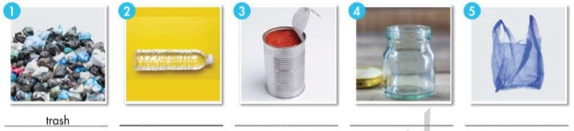

**Answers:**

|  |  |  |  |  |
| --- | --- | --- | --- | --- |
| 1. trash | 2. plastic bottle | 3. can | 4. glass jar | 5. plastic bag |

**b. Match the underlined words to the definitions. Listen and repeat.**

|  |  |
| --- | --- |
| 1. Our school likes to **recycle** students' used note paper.  2. I don't like to **throw away** anything that I can use again.  3. I **reuse** bottles in my garden and grow plants in them.  4. I always **pick up** trash on the beach when I see it. | **a.** collect and remove  **b.** use something for another purpose  **c.** change trash into something different  **d.** put something in the trash can |

**Answers:**

|  |  |  |  |
| --- | --- | --- | --- |
| **1. c** | **2. d** | **3. b** | **4. a** |

1. recycle = change trash into something different

2. throw away = put something in the trash can

3. reuse = use something for another purpose:

4. pick up = collect and remove:

**c. Say what things you reuse.**

I reuse plastic bottles.

**Answers:**

I reuse plastic bags, used papers and cans and old clothes.

**\*Reading**

**Sally blogs about saving the environment. Read her tips and write "True" or "False."**

Hi, everyone!

People ask me all the time what we should do to protect the Earth.

Here are my top tips.

Reuse glass bottles and jars. You can use them in your kitchen, bathroom, or even your garden. Glass bottles are really useful.

Don't throw away old glass!

Recycle plastic bottles, cans, and paper. Find recycling bins near your house or school and take your recycling every week. It's very easy!

Pick up trash. Nobody likes to see it in their town. Picking up trash makes our towns look better. After picking up the trash, make sure you recycle it!

|  |  |
| --- | --- |
| 1. We should reuse glass bottles.  2. We shouldn't throw glass jars away.  3. It's difficult to recycle paper.  4. We can make where we live look better. | *True*  _____________  _____________  _____________ |

**Answers:**

|  |  |  |  |
| --- | --- | --- | --- |
| **1. True** | **2. True** | **3. False** | **4. True** |

**\*Grammar:**

**a. Listen and repeat.**

Recycle bottles and cans. Don’t use plastic bags.

**b. Fill in the blanks with positive or negative imperative statements.**

|  |  |
| --- | --- |
| 1. *Don’t use* plastic bags.  2. ________________ plastic bottles.  3. ________________ old newspapers.  4. ________________ papers in the park.  5. ________________ old cans to grow flowers in.  6. ________________ old clothes. | ***x***(use)  ✓ (reuse)  ✓ (recycle)  ✓ (pick up)  ✓ (reuse)  ***x*** (throw away) |

**Answers:**

|  |  |  |
| --- | --- | --- |
| **1. Don’t use** | **2. Reuse** | **3. Recycle** |
| **4. Pick up** | **5. Reuse** | **6. Don’t throw away** |

1. ***Don’t use*** plastic bags.

2. **Reuse** plastic bottles.

3. **Recycle** old newspapers.

4. **Pick up** papers in the park.

5. **Reuse** old cans to grow flowers in.

6. **Don’t throw away** old clothes.

**c. Rewrite the sentences as negative or positive imperatives.**

|  |  |
| --- | --- |
| 1. Don't recycle plastic bags and jars.  2. Throw away glass jars and old newspapers.  3. Don't pick up trash in the park.  4. Don't recycle plastic bottles and old magazines.  5. Don't reuse plastic bottles in your garden.  6. Throw away old clothes. | Recycle plastic bags and jars. |

**Answers:**

1. Recycle plastic bags and jars.

2. Don’t throw away glass jars and old newspapers.

3. Pick up trash in the park.

4. Recycle plastic bottles and old magazines.

5. Reuse plastic bottles in your garden.

6. Don’t throw away old clothes.

**d. Practice saying the sentences with a partner.**

**Answers:**

1. Recycle plastic bags and jars.

2. Don’t throw away glass jars and old newspapers.

3. Pick up trash in the park.

4. Recycle plastic bottles and old magazines.

5. Reuse plastic bottles in your garden.

6. Don’t throw away old clothes.

**\*Pronunciation**

**Focus on the /l/ sound.**

**b. Listen to the words and focus on the underlined letters.**

recycle, bottle

**c. Listen and repeat.**

**d. Read the words with the correct sound to a partner.**

**\*Practice**

**Take turns saying imperative sentences.**

Don’t throw away the trash.

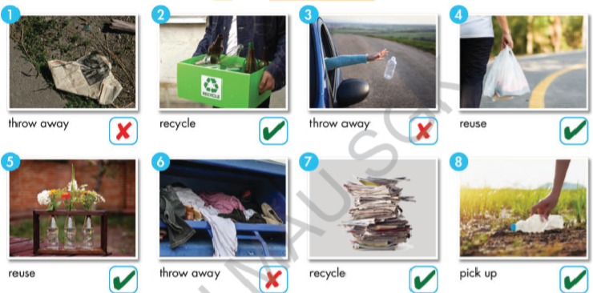

**Answers:**

2. Recycle plastic and glass bottles

3. Don’t throw away plastic bottles.

4. Reuse plastic bags.

5. Reuse plastic bottles to plant trees.

6. Don’t throw away clothes.

7. Recycle old papers.

8. Pick up trash/ plastic bottles.

**\*Speaking**

**Let’s Protect the Earth!**

**a. You want to write an article about how to protect the Earth. Work in pairs. Discuss and choose six tips to add to your notes.**

1. Pick up trash.

2. Recycle newspapers.

**Answers:**

3. Reuse plastic bags and bottles.

4. Don’t throw away old books.

5. Recycle glass bottles.

6. Reuse old clothes.

7. Recycle used cans.

8. Don’t throw old tires.

**b. Share your ideas with another pair. Now, discuss and choose three things you can do in your home or school.**

- I think saving electricity is important.

- I agree.

**Answers:**

**A:** I think at home we can reuse plastic bags and bottles, recycle used cans, and save water.

**B:** I completely agree with you.